HOW TO QUIT SMOKING
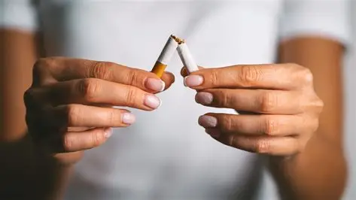
Smoking doesn’t relieve stress — it creates the stress that the next cigarette temporarily removes.
That’s the entire trap.

Nicotine causes micro-withdrawals all day
Every 20–40 minutes, nicotine levels drop. Your body sends a signal: something’s wrong. That signal feels like stress, tension, irritability, pressure in the chest or stomach — all the things you’ve described.

The cigarette removes the withdrawal — not the stress
You smoke, the withdrawal stops, and you feel “relief.” But that relief is just the baseline your body should have had all along.

There is HOPE for those who want to quit smoking…
There isn’t a fixed number — because quitting smoking isn’t one method, it’s an entire ecosystem of approaches. But based on authoritative sources, you can group the methods into five major categories, each containing multiple specific techniques. Together, they add up to dozens of distinct ways to quit.
HOW TO QUIT SMOKING
TEXT

